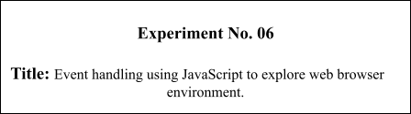

# Batch: B-4 Roll No.: 16010422234 Name: Chandana Ramesh Galgali

# Experiment No.: 6

**Aim**: Event handling using JavaScript to explore web browser environments.

**________________________________________________________________________________**

# Resources needed: Notepad++, Web Browser

**________________________________________________________________________________**

# Theory:

An HTML event can be something the browser does, or something a user does.

Here are some examples of HTML events:

An HTML web page has finished loading

An HTML input field was changed

An HTML button was clicked

Often, when events happen, you may want to do something. JavaScript lets you execute code when events are detected.

HTML allows event handler attributes, with JavaScript code, to be added to HTML elements.

# What can JavaScript Do?

Event handlers can be used to handle, and verify, user input, user actions, and browser actions:

* Things that should be done every time a page loads
* Things that should be done when the page is closed
* Action that should be performed when a user clicks a button
* Content that should be verified when a user inputs data

Many different methods can be used to let JavaScript work with events:

* HTML event attributes can execute JavaScript code directly
* HTML event attributes can call JavaScript functions
* You can assign your own event handler functions to HTML elements
* You can prevent events from being sent or being handled

# Syntax:

<element event='some JavaScript'>

<element event="some JavaScript">

# Example

In the following example, an onclick attribute (with code), is added to a <button> element:

<!DOCTYPE html>

<html>

<body>

<button onclick="document.getElementById('demo').innerHTML=Date()">The time is?</button>

<p id="demo"></p>

</body>

</html>

# JavaScript HTML DOM Events

HTML DOM allows JavaScript to react to HTML events:

JavaScript can be executed when an event occurs, like when a user clicks on an HTML element. To execute code when a user clicks on an element, add JavaScript code to an HTML event attribute:

onclick=JavaScript

# EXAMPLE

<!DOCTYPE html>

<html>

<body>

<h1 onclick="this.innerHTML='Ooops!'">Click on this text!</h1>

</body>

</html>

______________________________________________________________________________

# Activity:

Apply following JS events on your web pages

Input Events

* Onblur
* onreset

Mouse Events

* Onmouseover
* Onmousedown

Click Events

* Onclick
* Ondbclick

Apply following DOM events to your webpages

* Onload
* Onchange
* onmouseover

______________________________________________________________________________

# Results: (Program printout with output)

**<!DOCTYPE html>**

**<html lang="en">**

**<head>**

**<meta charset="UTF-8">**

**<meta name="viewport" content="width=device-width, initial-scale=1.0">**

**<title>Scent Haven - Your Perfume Destination</title>**

**<style>**

**body {**

**font-family: Arial, sans-serif;**

**margin: 0;**

**padding: 0;**

**background-color: #f3f0f3;**

**color: #3f393f;**

**}**

**.container {**

**max-width: 800px;**

**margin: 20px auto;**

**padding: 20px;**

**background-color: #fff;**

**box-shadow: 0 0 10px rgba(0, 0, 0, 0.1);**

**border-radius: 8px;**

**}**

**h1, h2 {**

**color: #3f393f;**

**}**

**.section {**

**margin-top: 30px;**

**text-align: left;**

**}**

**.section h2 {**

**margin-bottom: 20px;**

**}**

**.testimonial {**

**margin-top: 20px;**

**border-top: 1px solid #ccc;**

**padding-top: 20px;**

**}**

**.testimonial p {**

**font-style: italic;**

**}**

**.product-display {**

**text-align: center;**

**}**

**.product-image {**

**width: 200px;**

**transition: transform 0.2s;**

**}**

**.product-image:hover {**

**transform: scale(1.1);**

**}**

**select, button {**

**margin-top: 10px;**

**padding: 10px 20px;**

**font-size: 16px;**

**cursor: pointer;**

**border: none;**

**border-radius: 4px;**

**background-color: #3f393f;**

**color: #fff;**

**transition: background-color 0.3s;**

**}**

**select:hover, button:hover {**

**background-color: #574f57;**

**}**

**input[type=email] {**

**padding: 10px 15px;**

**font-size: 16px;**

**border: 1px solid #ccc;**

**border-radius: 4px;**

**box-sizing: border-box;**

**width: calc(100% - 32px);**

**margin-bottom: 10px;**

**}**

**input[type=email]:focus {**

**outline: none;**

**border-color: #574f57;**

**}**

**.quiz {**

**background-color: #f9f9f9;**

**padding: 20px;**

**border-radius: 8px;**

**}**

**.quiz-question {**

**margin-bottom: 20px;**

**}**

**.quiz-answer {**

**margin-bottom: 10px;**

**}**

**.quiz-answer label {**

**display: block;**

**margin-bottom: 5px;**

**}**

**</style>**

**</head>**

**<body onload="showDailySpecial()">**

**<div class="container">**

**<header>**

**<h1>Welcome to Scent Haven</h1>**

**<div class="email-signup">**

**<input type="email" id="email" onblur="validateEmail()" placeholder="Enter your email to subscribe">**

**</div>**

**</header>**

**<main>**

**<section class="daily-special" id="dailySpecial"></section>**

**<section class="product-display">**

**<h2>Featured Product</h2>**

**<img src="product.jpg" alt="Perfume" class="product-image" onmouseover="showNotes()" onmouseout="hideNotes()">**

**<p id="notes" style="display:none;">Indulge in the luxurious scent of roses, with hints of jasmine and vanilla.</p>**

**<button onmousedown="playAd()">Discover the Scent</button>**

**<button onclick="addToCart()">Add to Cart</button>**

**</section>**

**<section class="quiz">**

**<h2>Find Your Signature Scent</h2>**

**<form id="perfumeQuiz" onreset="resetQuizFeedback()">**

**<p>Take our quiz to discover the perfect fragrance for you.</p>**

**<div class="quiz-question">**

**<p>1. What scents do you prefer?</p>**

**<div class="quiz-answer">**

**<input type="checkbox" id="floral" name="scent" value="floral">**

**<label for="floral">Floral</label>**

**</div>**

**<div class="quiz-answer">**

**<input type="checkbox" id="woody" name="scent" value="woody">**

**<label for="woody">Woody</label>**

**</div>**

**<div class="quiz-answer">**

**<input type="checkbox" id="fruity" name="scent" value="fruity">**

**<label for="fruity">Fruity</label>**

**</div>**

**<div class="quiz-answer">**

**<input type="checkbox" id="oriental" name="scent" value="oriental">**

**<label for="oriental">Oriental</label>**

**</div>**

**</div>**

**<div class="quiz-question">**

**<p>2. How would you describe your style?</p>**

**<div class="quiz-answer">**

**<input type="radio" id="elegant" name="style" value="elegant">**

**<label for="elegant">Elegant</label>**

**</div>**

**<div class="quiz-answer">**

**<input type="radio" id="casual" name="style" value="casual">**

**<label for="casual">Casual</label>**

**</div>**

**<div class="quiz-answer">**

**<input type="radio" id="adventurous" name="style" value="adventurous">**

**<label for="adventurous">Adventurous</label>**

**</div>**

**<div class="quiz-answer">**

**<input type="radio" id="romantic" name="style" value="romantic">**

**<label for="romantic">Romantic</label>**

**</div>**

**</div>**

**<button onclick="submitQuiz()">Submit</button>**

**<button type="reset">Start Over</button>**

**</form>**

**</section>**

**<section class="collection">**

**<h2>Discover Our Collection</h2>**

**<p>Explore our exquisite collection of perfumes, each crafted with passion and expertise.</p>**

**<p>Our collection includes a wide range of scents, from fresh and floral to warm and woody.</p>**

**</section>**

**<section class="testimonials">**

**<h2>Customer Testimonials</h2>**

**<div class="testimonial">**

**<p>"I'm in love with the scent! Absolutely stunning!" - Emily</p>**

**</div>**

**<div class="testimonial">**

**<p>"Scent Haven has become my go-to for all things fragrance. Highly recommend!" - Alex</p>**

**</div>**

**<div class="testimonial">**

**<p>"The perfumes from Scent Haven are like magic in a bottle. I feel elegant every time I wear them." - Sophia</p>**

**</div>**

**</section>**

**<section class="contact">**

**<h2>Contact Us</h2>**

**<p>If you have any questions or need assistance, feel free to reach out to us:</p>**

**<p>Email: info@scenthaven.com</p>**

**<p>Phone: 1-800-SCENTHAVEN</p>**

**</section>**

**</main>**

**</div>**

**<script>**

**function validateEmail() {**

**var email = document.getElementById('email');**

**if (!email.value.includes('@')) {**

**alert('Please enter a valid email address.');**

**email.focus();**

**} else {**

**alert('Thank you for subscribing!');**

**}**

**}**

**function submitQuiz() {**

**var selectedScents = [];**

**var scentCheckboxes = document.querySelectorAll('input[name="scent"]:checked');**

**scentCheckboxes.forEach(function(checkbox) {**

**selectedScents.push(checkbox.value);**

**});**

**var selectedStyle = document.querySelector('input[name="style"]:checked');**

**if (selectedScents.length === 0 || !selectedStyle) {**

**alert('Please answer all questions.');**

**} else {**

**var scentString = selectedScents.join(', ');**

**var style = selectedStyle.value;**

**var result = 'Based on your preferences (Scents: ' + scentString + ', Style: ' + style + '), we recommend the following perfumes: Perfume A, Perfume B, Perfume C.';**

**alert(result);**

**}**

**}**

**function resetQuizFeedback() {**

**alert('Quiz reset. Discover your ideal scent!');**

**}**

**function showNotes() {**

**document.getElementById('notes').style.display = 'block';**

**}**

**function hideNotes() {**

**document.getElementById('notes').style.display = 'none';**

**}**

**function playAd() {**

**alert('Envision a garden in full bloom, every breath filled with a complex, captivating fragrance.');**

**}**

**function addToCart() {**

**alert('Elegance is on its way. Your perfume has been added to the cart!');**

**}**

**function showDailySpecial() {**

**document.getElementById('dailySpecial').innerHTML = 'Today’s Special: 20% off on Rose Elixir!';**

**}**

**</script>**

**</body>**

**</html>**

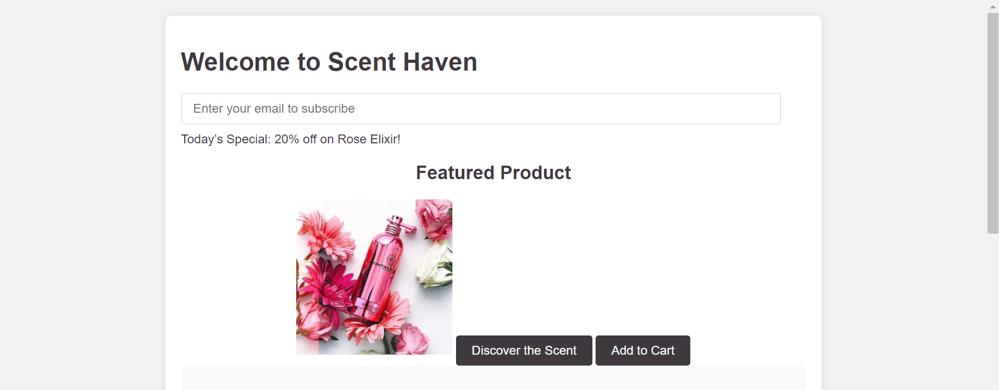

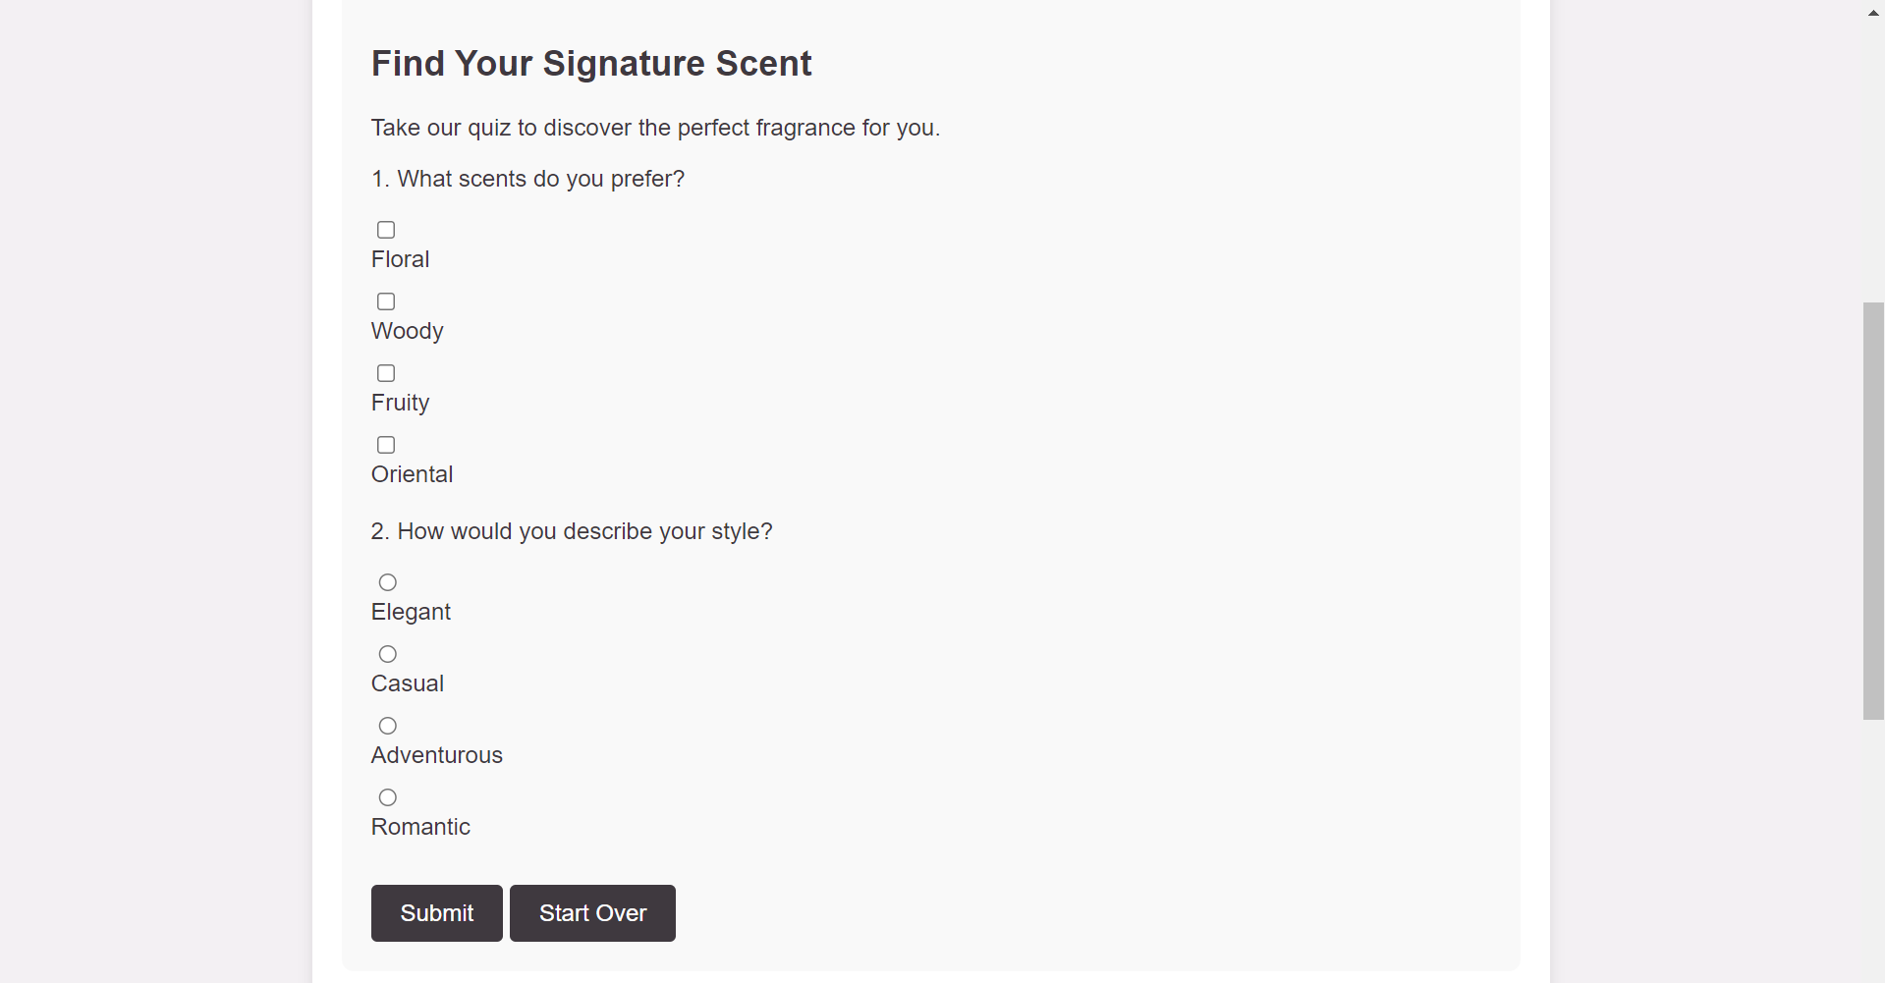

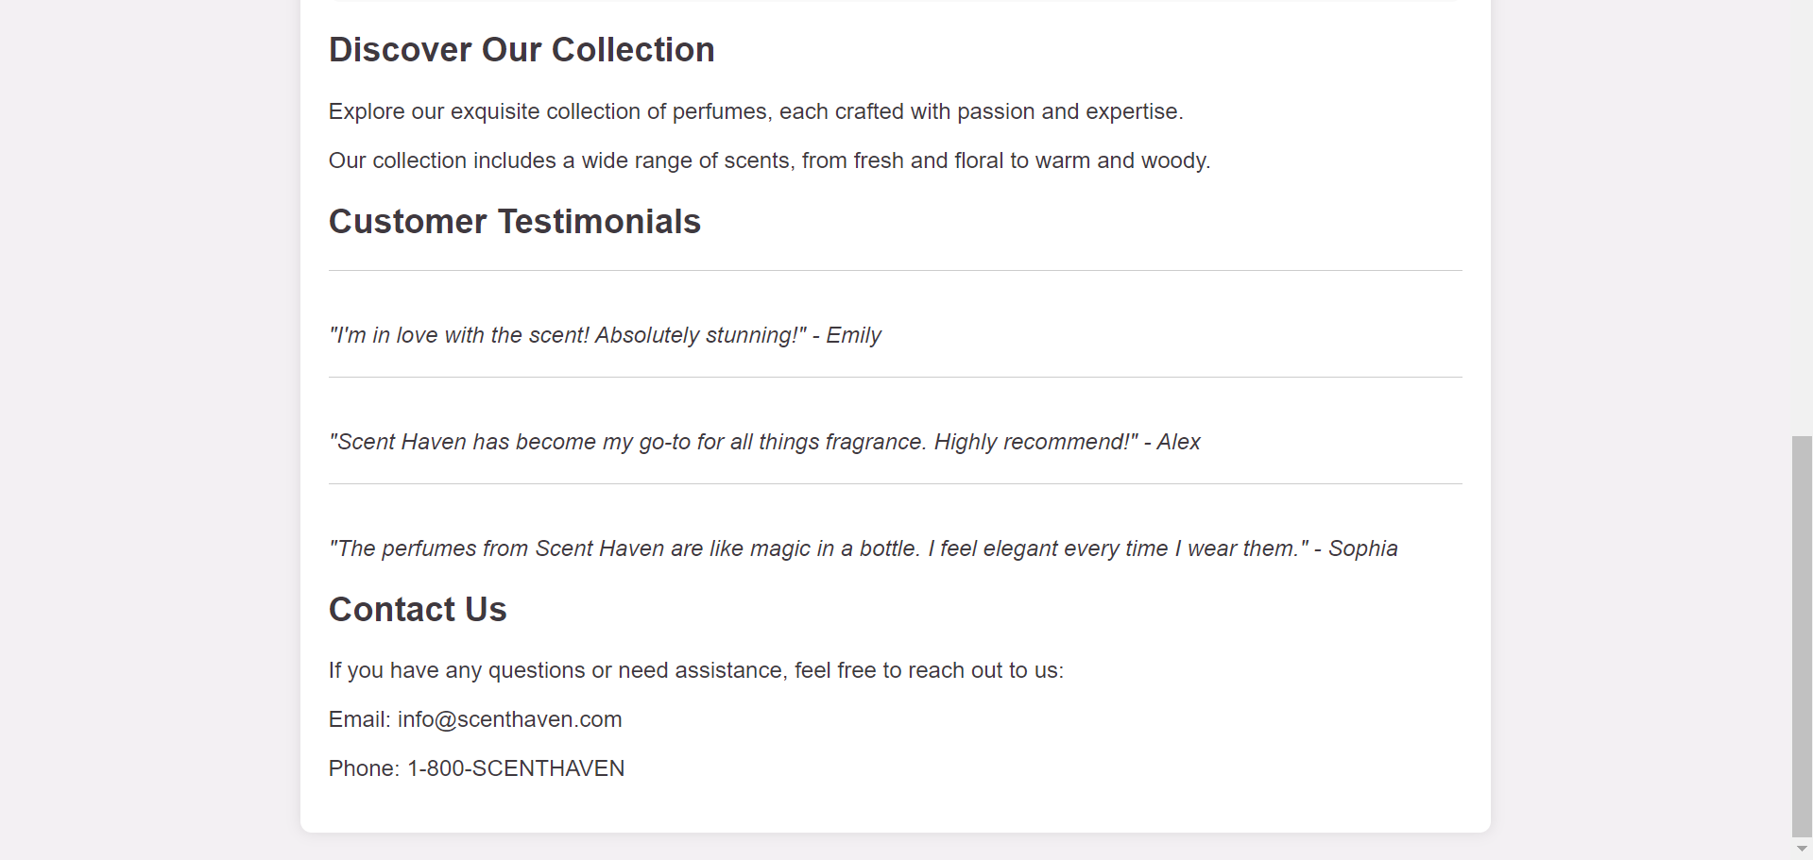

**________________________________________________________________________________**

**Questions:**

**Q1) What are the different types of load events?**

**Ans:** In web development, there are various types of load events that occur during the lifecycle of a webpage. These events indicate different stages of the loading process. Some of the common load events include:

DOMContentLoaded: This event is triggered when the initial HTML document has been completely loaded and parsed, without waiting for stylesheets, images, and subframes to finish loading.

load: The load event is fired when the whole page, including its dependent resources like stylesheets, images, and subframes, has finished loading.

beforeunload: This event is triggered just before the document is unloaded. It allows you to display a confirmation dialog to the user asking if they really want to leave the page.

unload: The unload event is fired when the document is being unloaded from the window, either by navigating to another page or by closing the browser/tab.

These events are useful for executing JavaScript code at specific stages of the webpage's lifecycle, enabling developers to perform various tasks such as initializing components, handling user interactions, or cleaning up resources.

**Q2) Explain Onkeypress, onkeyup events.**

**Ans:** onkeypress: This event occurs when a key is pressed down while the focus is on an element. It typically fires for printable characters (letters, numbers, symbols) but not for non-printable keys (such as Shift, Alt, Ctrl).

Example:

<input type="text" onkeypress="myFunction(event)">

<script>

function myFunction(event) {

console.log("Key pressed: " + event.key);

}

</script>

onkeyup: This event is triggered when a key is released after being pressed down. It also fires for printable characters and non-printable keys.

Example:

<input type="text" onkeyup="myFunction(event)">

<script>

function myFunction(event) {

console.log("Key released: " + event.key);

}

</script>

These events are commonly used to capture user input from the keyboard and perform actions accordingly, such as validating input, triggering search functions, or navigating through a form.

**________________________________________________________________________________**

# Outcomes: Apply JavaScript and JSON for Web Application development

**________________________________________________________________________________**

**Conclusion: (Conclusion to be based on the outcomes achieved)**

The experiment has provided a solid foundation in event handling using JavaScript within web browser environments. This knowledge is fundamental for web developers to create engaging and interactive user experiences on the web. Continued exploration and practice in event-driven programming will further strengthen our ability to build robust and responsive web applications.

**________________________________________________________________________________**

**Grade: AA / AB / BB / BC / CC / CD /DD**

**Signature of faculty in-charge with date**

**________________________________________________________________________________**

# References:

**Books/ Journals/ Websites:**

* “Web technologies: Black Book”, Dreamtech Publications
* [http://www.w3schools.com](http://www.w3schools.com/)

**________________________________________________________________________________**